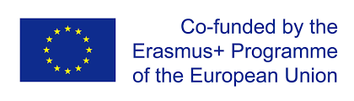 | ERASMUS KA219  „TheEuropeanChild: Learningbydoingthe 3 C's- Connect, Construct and Create”  Transnational project meeting in Bulgaria  28. 11. 2017 - 01.12. 2017 | 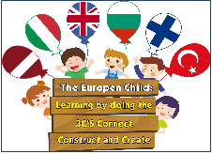

28. 11. 2017. Tuesday

Temple – monument ”St.Alexander Nefski”, National Theater ”Ivan Vazov”, Sofia University "St. Kliment Ohridski ", the Presidency, the Council of Ministers, the Court of Justice, the National Palace of Culture were visited.

29. 11. 2017. Wednesday
All partner school apart from the Italy attended 1.mobility of this project.
Kindergarten "Zvanche", Burgas was visited. Then “Welcome to Bulgaria”. Greetings from the children of the kindergarten was performed. We attended following “Child of nature” activities:
-mounting of bird-feeding houses on the trees of kindergarten "Zvanche" ,
-planting Erasmus tree ,
-visiting an exhibition of handworks made with natural and waste materials.
Transnational project meeting was held. Each school made presentation about their school and active learning/teaching activities.
Administrative tasks are planned. We discussed about the planning, management, responsibilities about the project.

30. 11. 2017. - 01.12. 2017. Thursday, Friday
Burgas Municipality was visited and taken information about the about teaching policy in the country,priorities in education.

Active learning seminar/workshop with the participation of Associate Professor Dr. HrissulaNedyalkova. Theme:"Constructivist Teaching / Learning Method and its close relative theory ''Active Learning'' was held.

Strandja Mountain, Brashlyan village, - Stoilovo village - Dokuzak waterfall were visited.
Veliko Tarnovo - the Old Bulgarian Capital / StaraPlanina Mountain The Tsarevets fortress hill.
We discussed about the theme "Child of Nature". Learn how to use different environments, materials, methods….. Observations, discussions.

