Title of activity  “I am an Artist” | Apple flowers from shaving foam
Age for children | 3-7 ages
Environment, materials | PVA glue, shaving foam, food colors, cotton sheets, paper pads.
Expected result | Children learn the features of the materials they use and how they can be used in painting.
Teacher's support for the child | The teacher presents the children with the characteristics of each material and proposes to mix them all in one mass.  Helps children work with the mass. Teacher supports and helps children in need of help.
Children's activities (planning, tasks, evaluation) | Children with the resulting mass cover the paper dishes, glued in the middle of the cotton plate.
Looking for answers to questions | How and where do you use the material that the children have learned?  What can else do with glue, food colors?  Where can else use shaving foam?
Attachment ( foto, video) | 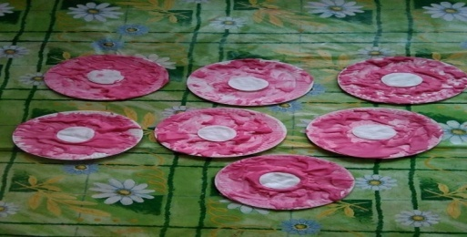 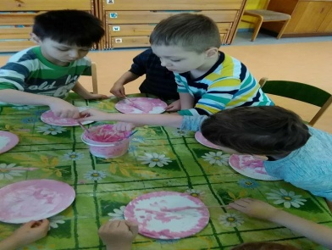 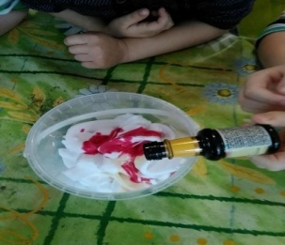 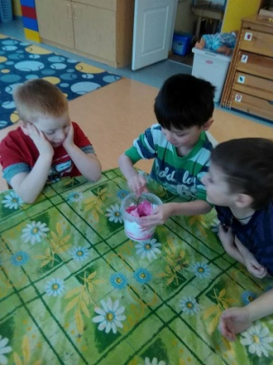

Author Ineta Tone , SPII “Valodina”, Dobele, Latvia

