Title of activity  “I am an Artist” | Freshening of fruits
Age for children | 3-7 ages
Environment, materials | Different fruits and vegetables, gouache color, cotton buds, glue
Expected result | Children have mastered a new drawing technique.  Children draw using a piece of fruit and vegetable  . Using PVA adhesive, slice the fruit or vegetable slice on paper and note the intended purpose
Teacher's support for the child | The teacher learns with the children the color and shape of the fruit and vegetables, find out what each child reminds them of, for example, apple slice of heart, orange slice of flower, etc.
Children's activities (planning, tasks, evaluation) | Children watches different fruit and vegetable slices ..  The children figure out what they associate with them, the like.  Kids stick fruit and vegetable slices and note the drawings of the design.  Rejoice at the result: paintings,
Looking for answers to questions | What can you do with fruits and vegetables? (Flounder, shape, color, flavor, use in painting)  Why do you think so?  How else can fruit and vegetables be used?
Attachment ( foto, video) | 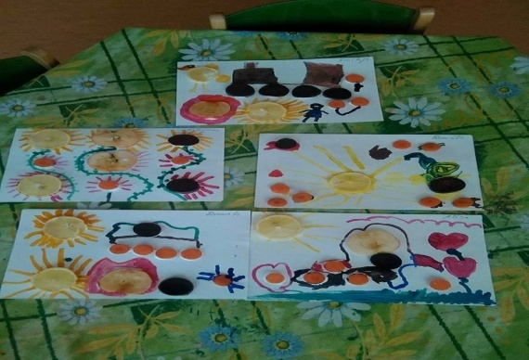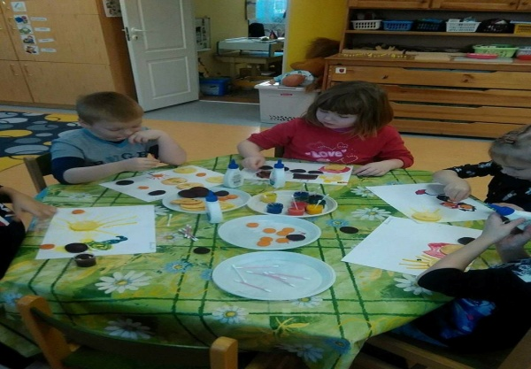
Author Ineta Tone SPII “Valodina”, Dobele, Latvia

