“I am an Artist” | Glass paining
Age for children | 3-8 age
Environment, materials | Glass bottles, vases, glasses, mugs, window glass etc.  Brushes, jar for water.  MARABU DECORGLASS glass paint (water base)
Expected result | Children have learned new paining technique. Children enjoy painting on glass surface.  Children draw:  - Specific paintings on glass objects (mugs, glass, bottle)  - mix different colors on the glass and observe what happens  - painting on window glass
Teacher's support for the child | Teacher starts to paint on the glass by herself, engaging children interest about painting on the glass.  Teacher supports children who need some assistance.  Teacher helps children to decide what they would like to paint on (vase, glass, candlestick).  Teacher helps to prepare all the needed materials.
Children's activities (planning, tasks, evaluation) | Children think about practical use of painted items:  - Painted jar can be used as lanterns if we put candle in it  - Painted bottles can be used as vase for flowers  - Painted window glass in the classroom can be used as decoration for some celebration.  - Mug for tea and so on.  Children notice more glass items on their daily life.  Children decides what they want to make.  Paints objects with glass colors. Paints with brushes or use other materials, for example sponge.  They are pleased with result: vases, candlesticks, paintings, present for mum, paintings on window, etc.
Looking for answers to questions | How to avoid braking the glass during work?  Does all glass brakes? Why you think so?  What kind of colors can be used on glass?  What can be drawn on glass?  What can be made from painted glass jars, bottles and other objects?  What else would you like to make?
Attachment ( foto, video) | 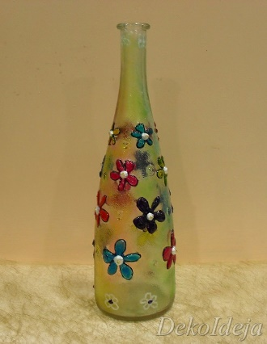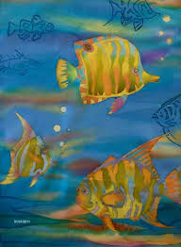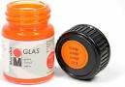
Author Mara Silova, SPII “Valodina”, Dobele, Latvia

