Title of activity | Painting with straw
Age for children | 4-7 years
Environment, materials | Cutted eggs made from cardboard, gouache colors, brush, water bowl, straws.
Teacher's support for the child | Teacher shows how to paint with straws. children are interested and watching how teacher is working. Today we are going to paint eggs with straws not brushes.
Expected result | children learned new painting technique. children like that blowing with straws shows different shapes. children know that you can paint differently. They are happy about what is done. children blow color drops – watching how colors are mixing and forming new colors.
Children's activities (planning, tasks, evaluation) | Children preparing to work – take colors, brush, pour water in bowl, take straw and cardboard eggs.  Choose colors with which they are going to paint eggs. With wet brush take colors and drop points on the eggs. Take straw and then blow the color drops on all the ways – forming different shapes.
Looking for answers to the questions | What colors we are using?  Name the basic colors!  What else can we paint with straw?  How strong you should blow with straw?  Do you like paint with straw?
Attachment ( foto, video) | 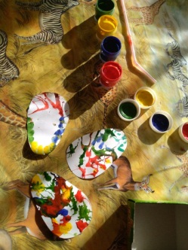  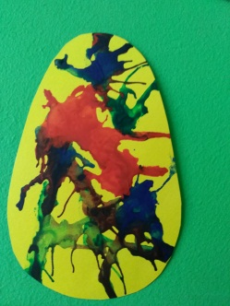  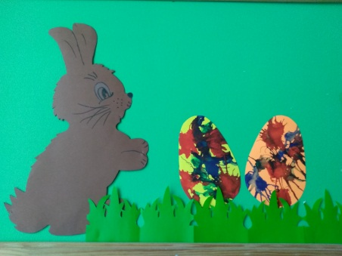  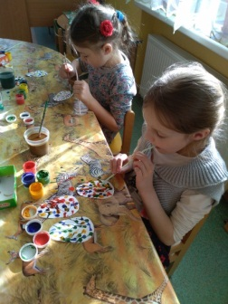
Author Daina Voitehoviča, SPII “Valodina”, Dobele, Latvia

