Title of activity | What the soil consists of? /Spring trip – planting and research/  Age: 6 - 7 years
Environment, materials | In the yard of the kindergarten or in the playroom and children's laboratory.  Materials: Jars with cap, soil, water, magnifying glass.
Teacher's support for the child | The teacher supplies the children's material and invites them to become scholarly researchers, but for that purpose they need to take a handful of soil from the yard of the kindergarten.  Encourages them to understand what the soil (earth) is, by doing together. Helps to carry out the experiment.
Expected result | Performing elementary experiment, children identify what the soil consists of – it is divided into several layers: stones, sands, clay, sticks, leaves.  On a practical basis, the children learn about the non-living nature and it matters to the living nature - the plants get water and nutrients from the soil, and some animals live underground.  Children are enthusiastic about entering the role of "researchers". Develop skills for selecting objects according to the role they perform.
Children's activities (planning, tasks, evaluation) | Children go out to take the soil needed to carry out the activity.  Put one or two handfuls of soil in a jar, add water, close the jars with a cap, then shake them to mix the water and the soil. About ten minutes they observe how the various components of the soil are separated - the heaviest stones are on the bottom, the sand above them, above the sand is the clay, and the lightest things (sticks and leaves) are on the top.
Attachment ( foto, video) | 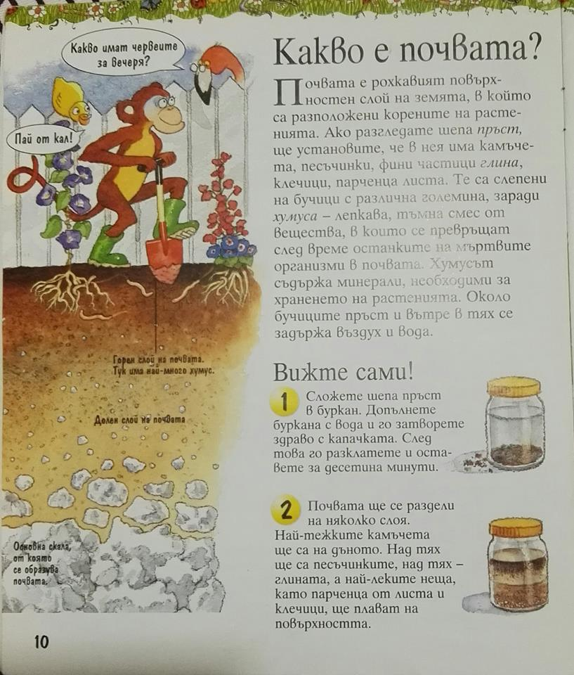
Looking for answers to the questions | What tools do scientists use?  What is needed for our experiments?  Which part of the plants is hidden in the soil?  How do the plants eat and receive water from the soil?  What the soil consists of?  What happened at the bottom of the jar?  And above the stones?  What is there at the top?
Source of information:,,Наука в градината”, Изд. ,,Фют’’ 2010
At home with science dig and sow,
Published by arrangement with Kingfisher Publications plc

