Title of activity | The drawing in grain crops.
Age for children | 4-7 age
Environment, materials | Table, different colors soft blankets, lentils, beans, sticks.
Teacher's support for the child | Children choose their desired table and grain crops. Mastered drawing in lentils and beans. A teacher takes pictures of children's drawings.
Expected result | Children feel pleasure in their palms. They know and name the grains (lentils, beans). They can draw in grains according their imagination and using their fingers, hands and sticks. Tell can tell what they have drawn. What was used for drawing?
Children's activities (planning, tasks, evaluation) | They listen to the calm, relaxing music, with their hands enjoying grains on the blankets. Children enjoy lentils and beans texture with their palms. They look at the drawing created by the teacher. With sticks, finger or palms they draw different stylized drawings in grains. At the end of the lesson, they tell about their work, working tools used and their feelings.
Attachment ( foto, video) | 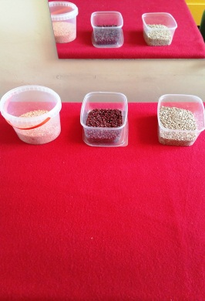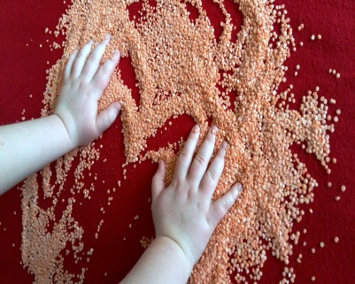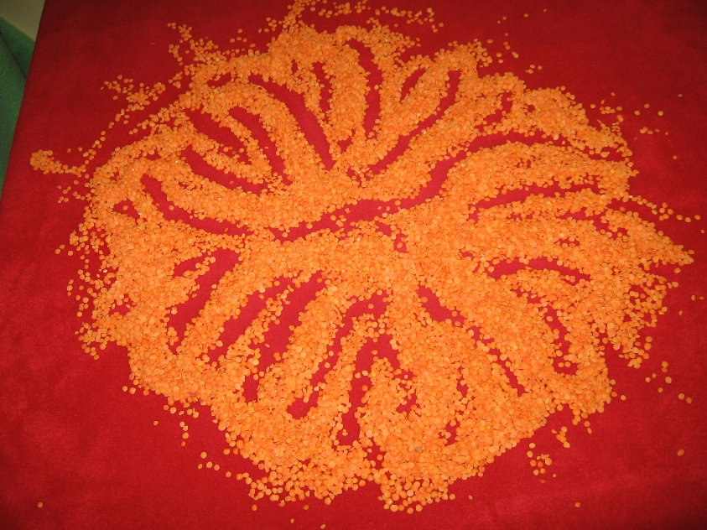
Looking for answers to the questions | Where lentils and beans are obtained?  What could be done using lentils and beans?  What might be used for drawing in grain crops?  Which tools are used for drawing and why?  What kind of feelings did they feel in palms?
Attachment ( foto, video) | 