Title of activity | Restaurant with delicacies for the birds/Winter trip - Designing bird feeders and putting in natural environment/  Age: 3 - 5 years old children
Environment, materials | Outside; At the kindergarten in the Autumn and Winter.  Materials:  I option – “ Bird Muffins”: wheat, millet, sunflower seeds, ready mix for birds, gelatin and cord, silicone molds for cakes.  II option - empty rolls of toilet paper, peanut butter, various seeds and raw nuts, cornflakes.  III option – “ Bird Cake”: deep bowl, spoon, orange - cut into two halves, a piece of hard fat, two handfuls of a mixture of bird seeds.
Teacher's support for the child | The teacher invites the children for a walking at the kindergarten’ territory and encourage them to explore the environment – plants, insects, birds.  The teacher has prepared materials for making birds feeders and ask children for help – what do the birds like to eat?  While little “cooks” prepare “delicious meals” for the birds, teacher supports and share with them interesting “recipes” for this.  This high calorie food for birds is prepared only during the cold months, in the Spring and Summer we put for the birds only pieces of fruit – apples, pears, bananas!
Expected result | Children learn how to feed birds and how to prepare bird feeders.  Children can take care of their feathered friends.  Children are happy because they saved the birds during the cold days when there is no food for them. They are satisfied with their work and can observe the birds coming.  Children learn about the life of birds that do not fly south, they observe their behavior and way of life. They consider the need for animal care and protection.
Children's activities (planning, tasks, evaluation) | Children prepare delicious meals for birds.  Mix all seeds and nuts for the birds.  Get acquainted yourselves with the products.  Every child chooses what kind of cake will do.  1. Dissolve the gelatin in a large bowl and add all the seeds. Fill the shapes with the mixture, put a string and top with a little dissolved gelatin. We leave them for a while to tighten the gelatin. 2. Roll out the toilet paper rolls with peanut butter and oval them in a mixture of seeds, nuts and cornflakes. 3.Add the seeds to the bowl of softened fat and mix, fill the carved orange fruit peel with the mixture.  Children help each other.  Finally, they put the cooked meals in different places, observing birds’ behavior.
Attachment ( foto, video) | I. 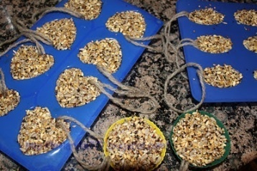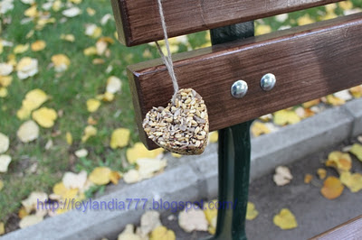  II.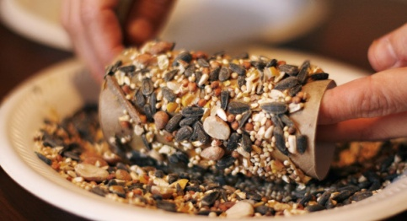III.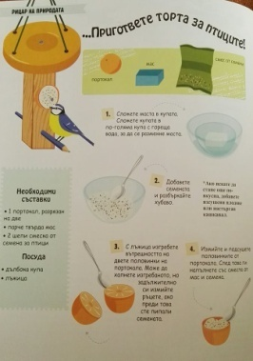
Looking for answers to the questions | How does the weather change in the autumn and the winter?  Are all birds flying in the South?  Who cares about those who stay here? How?  What do birds like to eat?  How do we prepare food for them?  Where do they live?  If we do not take care of the birds during the cold winter days what will happen to them?  What is the bird's body?  How many wings does it have, and its feet? How does he eat, what does he eat?  What kind of birds do you know? Where do they live in the Winter?
Source of information: Internet: http://feylandia777.blogspot.bg/2011/12/blog-post_10.html
http://www.informiran.bg
,,23 Ways to be an Eco Hero’’
Marshall Editions 2015

